Data Structures and Algorithms
Exercise 2: E-commerce Platform Search Function

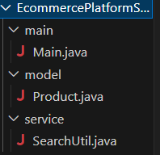
Product.java
package EcommercePlatformSearch.model;
public class Product {
public int productId;
public String productName;
public String category;

public Product(int productId, String productName, String category) {
this.productId = productId;
this.productName = productName;
this.category = category;
}

@Override
public String toString() {
return productId + " - " + productName + " (" + category + ")";
}
}

SearchUtil.java
package EcommercePlatformSearch.service;
import EcommercePlatformSearch.model.Product;
import java.util.Arrays;
import java.util.Comparator;
public class SearchUtil {
public static Product linearSearch(Product[] products, String name) {
for (Product p : products) {
if (p.productName.equalsIgnoreCase(name)) {
return p;
}
}
return null;
}
public static Product binarySearch(Product[] products, String name) {
int low = 0, high = products.length - 1;
while (low <= high) {
int mid = (low + high) / 2;
int cmp = products[mid].productName.compareToIgnoreCase(name);
if (cmp == 0) return products[mid];
else if (cmp < 0) low = mid + 1;
else high = mid - 1;
}
return null;
}

public static void sortProductsByName(Product[] products) {
Arrays.sort(products, Comparator.comparing(p -> p.productName.toLowerCase()));
}
}
Main.java
package EcommercePlatformSearch.main;
import EcommercePlatformSearch.model.Product;
import EcommercePlatformSearch.service.SearchUtil;

public class Main {
public static void main(String[] args) {
Product[] products = {
new Product(101, "Laptop", "Electronics"),
new Product(102, "Shoes", "Footwear"),
new Product(103, "Watch", "Accessories"),
new Product(104, "Mobile", "Electronics")
};

// Linear Search
Product result1 = SearchUtil.linearSearch(products, "Watch");
System.out.println("Linear Search Result: " + result1);

// Binary Search (sort first)
SearchUtil.sortProductsByName(products);
Product result2 = SearchUtil.binarySearch(products, "Watch");
System.out.println("Binary Search Result: " + result2);
}
}

OUTPUT
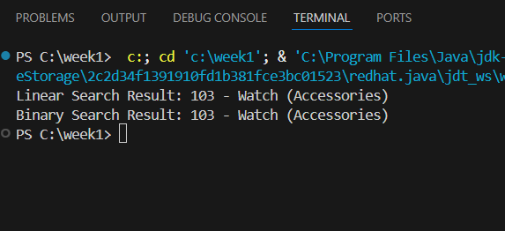

Exercise 7: Financial Forecasting
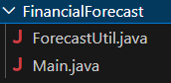
ForecastUtil.java
package FinancialForecast;
public class ForecastUtil {
// Recursive function to calculate future value
public static double futureValue(double presentValue, double rate, int years) {
if (years == 0) {
return presentValue;
}
return (1 + rate) * futureValue(presentValue, rate, years - 1);
}
// Optimized with Memoization (optional, for large n)
public static double futureValueMemo(double presentValue, double rate, int years, Double[] memo) {
if (years == 0) return presentValue;
if (memo[years] != null) return memo[years];
memo[years] = (1 + rate) * futureValueMemo(presentValue, rate, years - 1, memo);
return memo[years];
}
}
Main.java
package FinancialForecast;
public class Main {
public static void main(String[] args) {
double presentValue = 10000; // Rs. 10,000
double annualRate = 0.08; // 8% annual growth
int years = 5;
// Simple recursive
double result = ForecastUtil.futureValue(presentValue, annualRate, years);
System.out.println("Future Value (recursive): Rs. " + result);
// Memoized recursive
Double[] memo = new Double[years + 1];
double optimizedResult = ForecastUtil.futureValueMemo(presentValue, annualRate, years, memo);
System.out.println("Future Value (memoized): Rs. " + optimizedResult);
}
}
OUTPUT
